**AP HUMAN GEOGRAPHY**

Mrs. Nosek

2021-2022

**CONTACT INFORMATION**

-

Email: nosekj@gcsnc.com

Phone: 336.643.8449

Room #: 220

**COURSE DESCRIPTION**

This course is about people and the planet – how do they interact together? How does one affect the other? Why do some cultures thrive while others die out or struggle? We will study the relationship between people and the planet over space and time. This course is about interactions, connections, scale, diffusion and other geographic themes. Spatial tools like maps and GIS will be used to tell stories, analyze phenomena and solve problems humans and nature are faced with (that’s what a REAL geographer does…)

**REMIND CODE:** @8f9g4

**COURSE TEXT**

*AP Human Geography: Places and Regions in the Global Context 7th Edition*

**EXAM DATE**

The AP exam for this class is scheduled for 8 a.m., **Thursday, May 5th**

* 60 multiple choice questions in an hour and 3 FRQs in one hour and 15 minutes.
* This year there will be a fee associated with not sitting for the exam and no digital exams will be offered.

**CANVASS**

* Daily Announcements, Assignments, Discussions will be posted daily on the class CANVAS Page.

**EXPECTATIONS**

* Be on time, attentive, mature and involved. You are to act as an AP student.
* Do the readings and assignments to completion the day they are assigned.
* Raise your hand when you wish to speak and remain quiet and respectful when someone else is speaking.
* Be aware of technology etiquette – cell phones may be used in conjunction with **specified** activities. Do not pull phones out without asking first. Phones will be confiscated on-site and the appropriate electronics use policy will be followed without exception.
* No food or drink is to be permitted in class, aside from water.
* Communication is critical – students are expected to take the initiative to ask questions when they feel confused or need clarification, announce future absences so they may prepare adequately to stay on-track with the course, and provide insight in to the information learned in class.

**COURSE GOALS**

* *Use and think about maps and spatial data*. Maps are a geographer’s primary tool (both paper and online). You should be able to read them, interpret them, use them to analyze situations, solve problems, etc. You should also understand that they are not perfect!
* *Understand and interpret the implications of associations among phenomena*. You should be able to hypothesize about the relationships between things on the planet.
* *Recognize and interpret at different scales the relationships among patterns and processes*. You should be able to compare and contrast things between local and global levels. (What happens at one scale affects another scale).
* *Define regions and evaluate the regional process*. Regions can be defined in many ways. These regions are keys to understanding locations and their connectedness.
* *Characterize and analyze changing interconnections among places*. You should be able to analyze and understand the connections between places over space and time. You should also be able to take this further and hypothesize, understand or explain WHY those changes are occurring.

**WRITING EXPECTATIONS**

Students in AP Human Geography should have a solid foundation of composition and inquiry-based writing skills that will be used in research writing. Writing will be conducted on a daily basis from anywhere to one-paragraph to multi-page essays. There will be multiple opportunities to share through writing- personal experiences, interpretations, analysis, and evaluations throughout the course of the school year. There will also be many opportunities for collaborative/group writings to further expand writing skill and ability.

**READING EXPECTATIONS**

This course will require a consistent routine of nightly readings from the class textbook, related articles, and other supplemental resources in print and online. Students taking this course should be capable of reading an extensive amount of pages each night. After breaking down essential text, the student should be able to analyze, interpret, and reflect upon the material in a spatial viewpoint. A common component of this class will be to challenge data for relevance and connection to the curriculum. Alongside text, students will need to be able to analyze maps, graphs, and data-tables to make further links to the course standards and concepts.

**GRADE BREAKDOWN- This is subject to change**

Tests/Large Projects: 50%

Quizzes/Small Projects: 30%

* Some “mini projects” will count as two quiz grades

Daily Assignments: 20%

**GRADING COMPONENTS**

*First and foremost* everything done in this class is not a grade. Students taking this course must be mature enough to recognize that everything has relevance and meaning toward the final exam and should approach all tasks with maximum effort. It is expected that any student who is failing or struggling should come for extra review and tutorial. Begging for extra credit or simplified tasks will yield nothing in both the short and long term.

***Tests*** will be announced well in advance. These are sometimes given in a two-day span; 30-40 Multiple Choice Questions the first day, 2-3 Free Response Questions the second day. Tests will require students to evaluate images, documents, graphs, and expand upon essential concepts, vocabulary, and perspectives learned in class. Test questions are also application-based with scenarios and real-world events to help students prepare for the AP Exam. Later in the year, tests will be timed to simulate the AP testing experience. On testing day be prepared to turn in your cell phones.

**The social studies department assigned testing days are Wednesday and Friday**

***Quizzes*** are fairly frequent. These will include announced and unannounced quizzes. They may be on readings, chapter material, lecture material, required research, etc. Multiple formats will be used including short answer, multiple choice, fill-in-the-blank, etc. Map quizzes will be given both 1st and 3rd quarter to ensure retention. I will provide you with lists of countries and landforms that will need to be identified prior to the quizzes.

***Homework*** may include readings, questions, research, or other tasks. It is due on the assigned date for full credit. Students will need to be able to access articles online. Homework will still be given despite other assignments going on concurrently.

***Study Materials*** include things like note cards, readings, notes, etc. These will be collected periodically throughout the course. The purpose of this is to aid you in studying for the tests/quizzes.

***Case Studies*** are used to extend learning of concepts. This is the opportunity to apply textual information to real places and current situations. These assignments will be practiced routinely.

***Research, Tasks, and Presentations*** will be worked on when time permits in each unit. Each group will present and share their continental research that synthesizes and connects relevant unit material, concepts, and models.

***Small Projects*** are sometimes assigned as singular or group research activities. These quick, one to two day mini-projects highlight certain concepts or areas of note around the world. These will typically count as 1-2 quiz grades.

**TESTING**

All students are required to take the test on the assigned test date. If a student misses class the day prior to test day, the following guidelines will be followed:

1) if new material was presented in class, the student will not be required to take the test

2) if new material was not presented in class and the class was utilized as a review, the student will be required to take the test.

The Guilford County policy of allowing students three days to make up missed assignments will be followed.

**ATTENDANCE**

The attendance policy will be enforced as outlined by Northern Guilford High School.

**MAKE UP WORK AND LATE SUBMISSIONS**

Please ask me for missed work. Try to minimize absences if possible. Keep in mind that absences hinder progress. Looking at someone else’s notes is not the same. If you are absent, you are still responsible for any homework assignments upon your return. Maximum credit for late submission will be as follows:

Day 1: 85 Day 2: 70 Day 3: 50 Day 4 and after: 0

**ACADEMIC INTEGRITY**

Academic integrity is highly important to your success as a student. Academic dishonesty includes plagiarism, giving other students answers, copying other students’ answers, or providing content about class assessments to other students. Penalties for any of the above include zeros, administrative referrals, and poor recommendations for National Honor Society or other organizations that require academic integrity. This includes college and military applications.

**TENTATIVE SCHEDULE**

The AP exam date does not change even if we have snow days. Due to this, every attempt will be made to adhere to the schedule below as closely as possible. **You will be responsible for some of the textual information on your own as we will not have time to cover it all in class.** Below you will find the tentative schedule for major assessments. Be advised that there will often be other ancillary texts to read and/or videos to watch and reflect on as well. Again, these dates can change so please stay on top of your nightly reading.

* August 23 – First day
* **Unit I Test: Nature & Perspectives of Geography**
* **Unit II Test: Population & Migration**
* **Unit III Test: Cultural Patterns & Processes**
* **Unit IV Test: Political Organization of Space**
* **Unit V Test – Agricultural & Rural Land Use**
* **Unit VI Test –Industrial & Economic Development**
* **Unit VII Test – Cities & Urban Land Use**
* **Review**
* May 5th – **The AP Human Geography Exam at 8:00 a.m.**

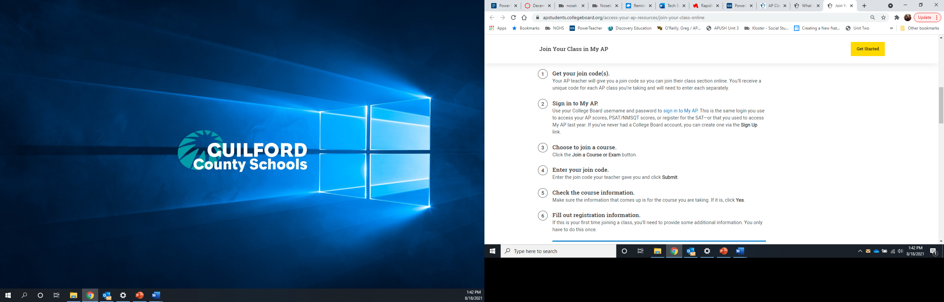**AP CLASSROOM**

* AP Classroom is an online resource for students enrolled in AP courses taught by authorized AP teachers.
* AP classroom will contain resources and online check-ins that we will complete throughout the year.
* Join Codes:
  + 2nd period- 479RMD
  + 6th period- 2AV733

**TIPS FOR SUCCESS**

* Taking good notes:
  + Take your own notes. Go over them multiple times and add onto them as you continue to learn.
  + Determine what’s important – if it is written on the board, repeated or emphasized, write it down.
  + Use word signals (“The first reason why…” – this should be a clue that you need space for multiple things and can help with organization)
  + Title and date everything so you know what it is later.
* Listen effectively:
  + If you come in thinking the class will be boring, it will be.
  + Avoid having side-bar conversations with your classmates – it’s rude, distracting to others, and can take place during class change.
  + Go into class expecting to participate and be ready for it. Students frequently not participating will be the first to be called upon!
* Keeping an open mind
  + In APHG we will be covering both domestic and international topics of all kinds. Some of these topics can evoke strong feelings and emotions. While your stance on these topics is your choice and business, how you present your ides/feelings should be respectful, especially when a disagreement occurs.

**UNITS AND CORRESPONDING CHAPTERS**

* Unit 1- ch. 1, 2, 4 (p.108-115)
* Unit 2- ch. 3
* Unit 3- ch. 5, 6
* Unit 4- ch. 10,7
* Unit 5- ch. 9, 4 (p. 116-127)
* Unit 6- ch. 8, 4 (p. 127-148)
* Unit 7- ch. 11, 12

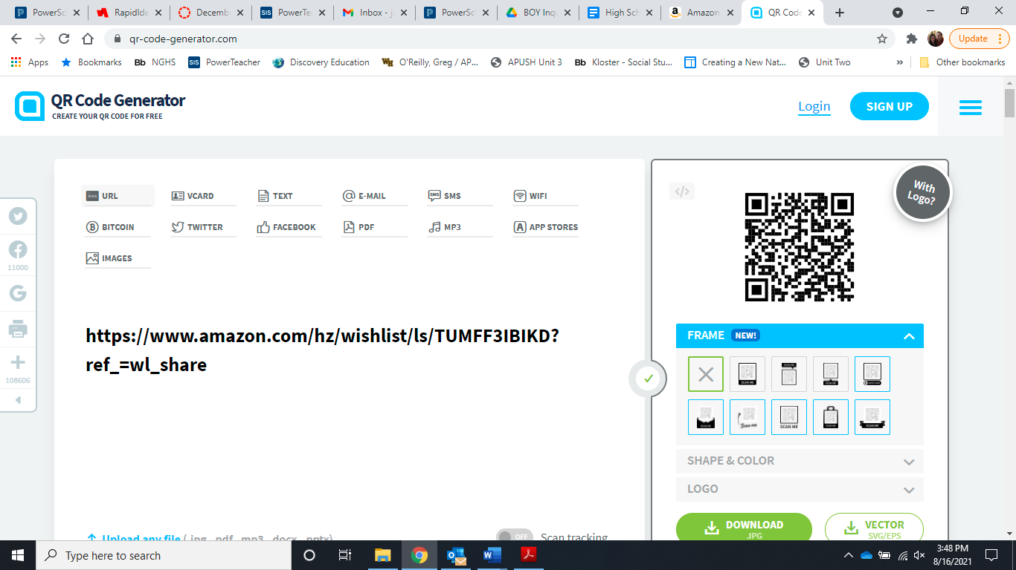

The QR code to the right is the link to the classroom wish list if you wish to contribute.

**Student Name:**  Last:________________ First:___________________

Dear Parents/guardians,

I am very excited about the new school year and want each parent to know that I am only an email or phone call away. I strongly believe that education is a "family affair". Therefore, it is always helpful when there is interest at home in student activity and progress in the class. Remember that this is a college-level course. Please keep in mind there is a possibility that your student will struggle a few times during the year. I am, and will continue to be available to help your child succeed, but they must learn to advocate for themselves and seek help when they are struggling. The AP Exam is not an easy test – student success is typically correlated to the level of work they put in. No student will be left to struggle on their own.

* It is important to read the syllabus. Please reach out if you have any questions or need clarification on anything covered in this document.
* The College Board Web Site: www.collegeboard.com. Here you can find information about AP credit, other AP offerings, and information about the exam. It also outlines important policies and procedures all AP teachers are bound to.
* Workload can be overwhelming at times – parental support is critical.
* I highly recommend your student purchase a review guide for the exam to use at the end of the year.
* I do not curve grades and I do not offer extra credit.
* There are no “drops” from an AP class. Please have your student see me early on if they are having issues with the class.
* This class will be rigorous and challenging, but it will also be fun and as “hands on” as possible! I am looking for guest speakers frequently – if you know anyone in the field related to any of the units we are covering, please contact me so that I may work them into our schedule.

Thank You!

Jamie Denny Nosek

**Parent/Guardian Contact Information:**

Parent/Legal Guardian 1 (Please Print Name) :________________________________________

Relationship to Student:________________________________________________

Email: __________________________________________

Phone: (Home) __________________________________

(Cell)____________________________________

Parent/Legal Guardian 2 (Please Print Name) :________________________________________

Relationship to Student:________________________________________________

Email: __________________________________________

Phone: (Home) __________________________________

(Cell)____________________________________

Student’s Email: __________________________________________

**\*\*\* Please sign below stating that you acknowledge and understand the expectations and requirements of this course as outlined in the syllabus.**

Student Signature: ________________________________

Parent/ Legal Guardian Signature: ________________________________